Big Sky Master Swimmers,
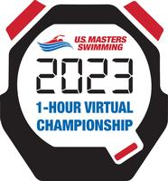
Let’s win the 1-Hour Virtual Championship!
If Big Sky Masters Swim wins proceeds will be used to rent the pool for the 2023 Montana Masters Swim Championship Swim Meet in Butte March 18-19. Join the team and swim the Hour.
If you are not a 2023 USMS member, join USMS or renew your membership USMS registration webpage.
HOUR SWIM: All participants must register prior to swimming the event and complete their swim between Jan. 1 -31.
Big Sky Masters would like to have the highest total participation. USMS has an extra incentive, offering a total of $3,500. Highest total participation: 1st $1,000, 2nd $500, 3rd $250.
Be part Big Sky team, swim fast, stop whenever you want or just float. But most of all have fun!
Hour Swim Events Details

Hour Swim ENTRY
Peggy Stringer
Big Sky Masters President

Helena Ridleys: The Helena YMCA has let us swim the HOUR from 8-9am MWF staring on Wednesday, January 11 and ending on Monday, January 30. Please signup with Peggy by texting her at 406-459-9748 with date you plan to swim or let her know at the pool.
On Wednesday, January 11 three swimmers have signed up. Please let Peggy know if you would like to swim on Wednesday with them. And signup ASPA!

